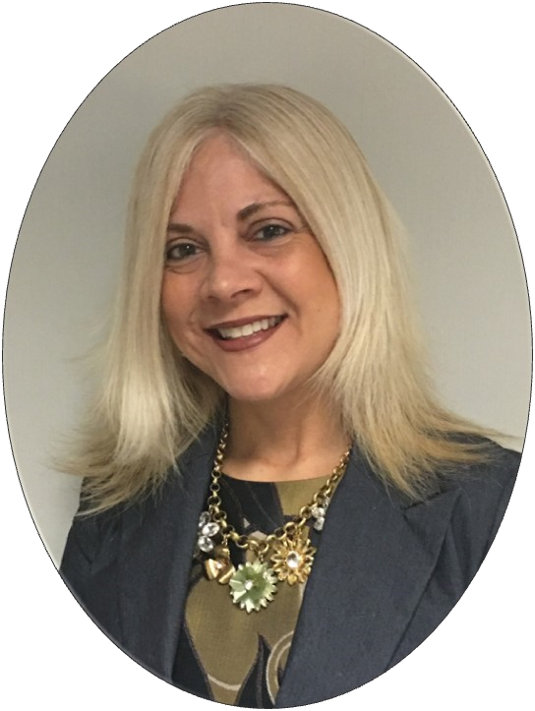
Geauga County ESC
Summer Newsletter

MESSAGE FROM THE SUPERINTENDENT
It is hard to believe that my first year as the Geauga County Superintendent is concluding and there are so many items that I would like to share with the staff, schools, and communities. As you read through our final newsletter of the school year, I would like to emphasize our ESC goals and planning process initiated in August 2016. Our goals are a direct focus on strengthening our programs and services for our students in Geauga County. We have an obligation to our schools and students to be fiscally sound, to have an agency that provides consistent and effective communication, and to hire and support staff to ensure quality service delivery. We will continue to work on our action steps towards achieving these goals in the 2017-2018 school year. I have appreciated the support of our staff and schools in providing the input and support needed to guide this process.
Throughout my career I have worked for and learned from the best superintendents that I was so fortunate to have the opportunity to learn from. I was encouraged early on in my career to always appreciate your staff and the relationships of my colleagues. I have reflected a great deal on these "words of wisdom" this school year - especially the importance of listening to our schools and solidifying strong relationships. This also comes with being involved and present in our programs, communities, and visiting our schools. Presenting at the Cardinal Local Schools community forums, being a presenter at the State of Geauga Symposium, and to be the featured speaker at the senior citizens dinner in West Geauga Local Schools are examples of making connections with our schools and community. I am honored to have had these opportunities to meet such amazing people in Geauga County.
In summary, I want to share that I have continued to be involved in Columbus in order to have a voice and utilize my relationships created in my former position as Associate State Superintendent. Continuing to work with our legislature and the Ohio Department of Education is essential in my role as county superintendent. I am often asked to be a part of state committees and invited to many Geauga Leadership meetings for various organizations and have appreciated learning from the key leaders in our county. I look forward to next school year and continuing to offer successful programs and services to Geauga County and beyond. Our dedicated staff will continue to work hard to ensure success for our students. I also want to thank our Governing Board of Education, staff, and school leaders for embracing my presence in the county and supporting the changes I have made for a stronger future.
Geauga County ESC Goals 2016-2018
1. Finances—Billing Structures and Program Cost Analysis
To improve general fund revenue and to build confidence/transparency in billing practices 2. Communication/Public Relations
Systemize and expand agency communications with educators, employees, community/parents 3. Professional Development and Staffing Analysis
Build external credibility through credentialed staff and quality service delivery

Teacher of the Year
The Geauga County Innovative Teacher of the Year
Award Program is a partnership between the Geauga County ESC and Geauga County business and industry leaders. This special recognition is awarded to one Geauga County full-time K-12 teacher. The goal of this program is to recognize one outstanding teacher who employs novel and innovative teaching methods to achieve student success in learning.

The 2016-2017 Geauga Innovative Teacher of the
Year Award was given to Maureen Fowler, a
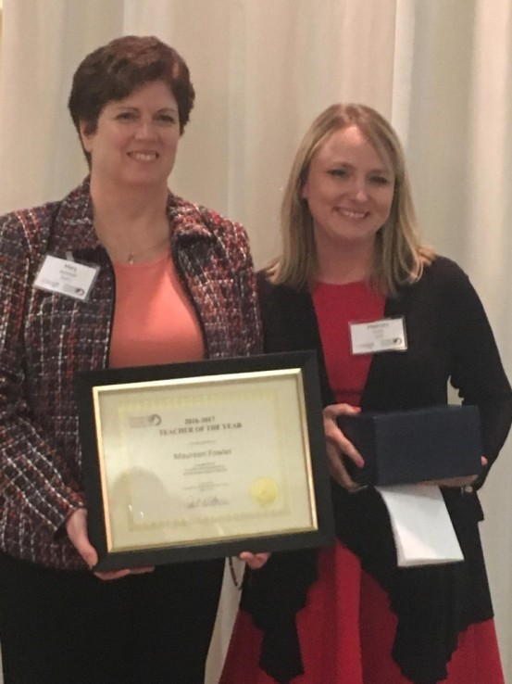
High School English teacher at Cardinal Local Schools. Maureen has lead professional development activities this year with her colleagues regarding the integration of technology and 21st century skills into daily instruction. She has been a leader in helping Cardinal staff transform the way they teach and utilize tools, such as iPads, to enhance the learning of students.

Mary McFarland, Sr. Talent Manager, Kinetico presented this award to Maureen at the All Boards Dinner on May 3rd, 2017. As part of this partnership, Kinetico will sponsor Maureen to attend a State of National Conference of her choice up to $1,500.00.
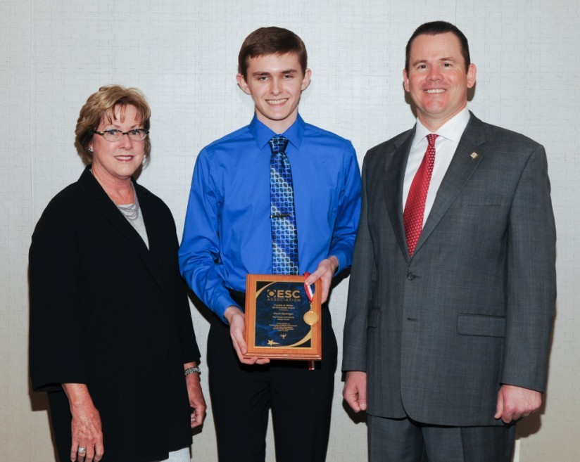
Franklin B. Walter All-Scholastic Award Program

The Franklin B. Walter All-Scholastic This year’s Franklin B. Walter
Award Program was established by the Award recipient is David
Ohio Educational Service Center Sprenger from West Geauga
Association (OESCA) to promote Local Schools. David has demonstrated and recognize outstanding academic outstanding academic achievement achievement. One senior from each throughout his school years while parcounty in Ohio will receive this an- ticipating in a wide array of school, nual honor. Applicants must be a community and competitive activities. high school senior enrolled within a David and his parents along with West public school in the Geauga County’s Geauga High School Principal, Jay service region. Recipients should Bishop, and Suzanne Allen, GCESC demonstrate outstanding academic Assistant Superintendent attended an achievement as indicated by high award ceremony and luncheon in school grades, test scores and school Columbus on April 12th,
Suzanne Allen, Geauga County ESC Assistant Superintendent, activities and awards. 2017.
David Sprenger, Award Recipient and Doug Crooks, Superintendent of North Point ESC.
Geauga Academy, Donna Cook
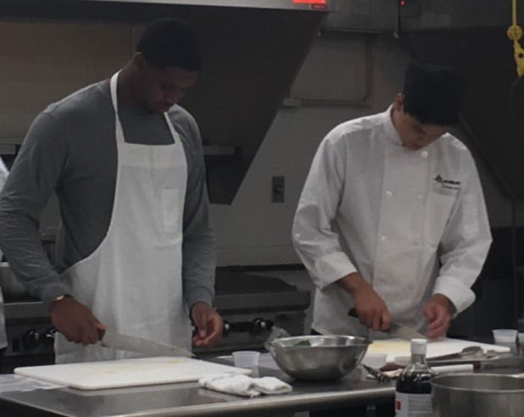
The best way to demonstrate what you have learned is to teach it to someone else. The best way to spend a Friday afternoon is cooking with new friends. The Auburn Culinary students paired up with the Geauga Academy students to prepare a meal. Our culinary friends walked the GA students through a delicious pasta recipe, showing us proper ways to cut basil, chop garlic, and dice onions. The end result was a fantastic lunch shared by all. The culinary students even made us cupcakes for good measure. It was a great way for the culinary students to show off what they have learned while teaching us some new skills.
Vocational Consortium, Jaina Gandolfi
Students, Teachers, Parents, and, Job Coaches spent
Monday May 16th at Punderson State Park in order to celebrate
the year’s accomplishments and the coming of summer. Students worked very hard throughout the year gaining valuable vocational and life
skills in various job sites
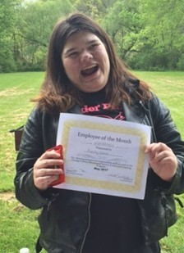
throughout the community. There were many graduates of the Job Training Program who were acknowledged and received a warm send off into their adult ventures. Several students were awarded Employee of the Month Awards as well. These student displayed excellence on the job, and were acknowledged with a certificate of excellence. Teachers and the vocational team created a new award to acknowledge a valued and missed member of the team, Christine Polan.
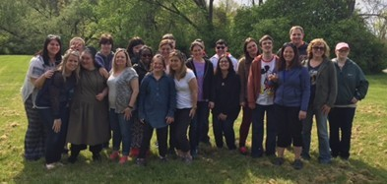
Christine was the epitome of kindness, warmth and respect. Two students were chosen as demonstrating these qualities and received the Christine Polan Award. Many delicious treats were enjoyed, games were played and lots of fun was had by all!

Now that summer is almost upon us, there are an abundance of summer work opportunities! Several students will be supported dur-
ing the summer through Work Study, while gaining skills and earning money. Students can contact the GCESC Website for job postings, or, Sarah Drewlo, The Transition Coordinator for information on employment leads, applications and interviews.

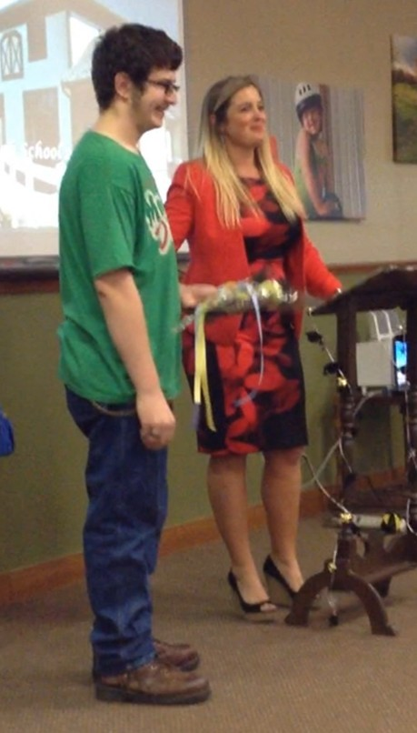
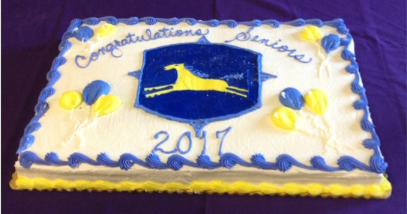
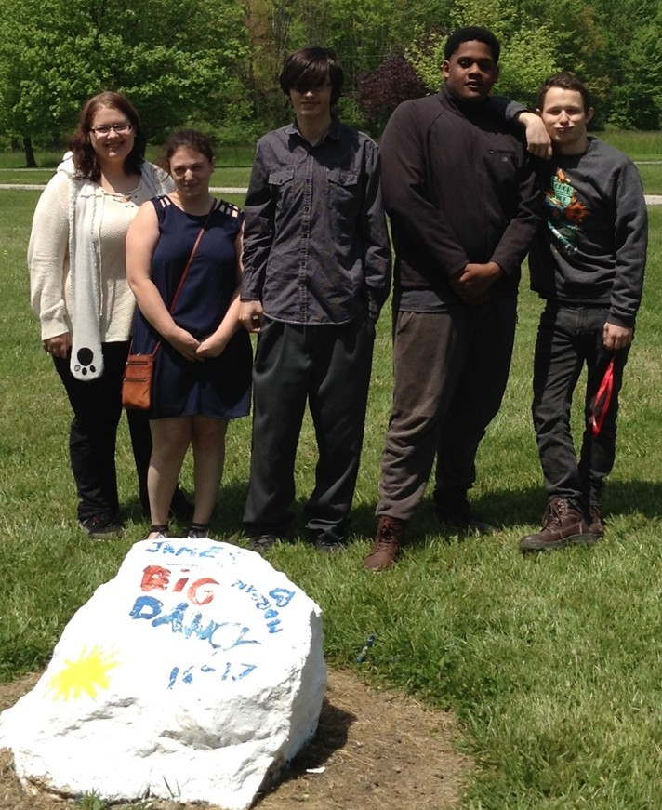
Gaitway, Lindsay Baar
Gaitway High School said good
bye to 6 graduates this school
year. One has signed to play
football at Gannon University,
another will be attending Roch-
ester Technical Institute, one is
looking into Tri
-

C Community
College and the others are
entering the work force. We
are extremely proud of the
handful of students that are
transitioning from Gaitway to the
next step in their educational jour-
ney.

As of now, we have one opening on our class list for the 2017-2018 school year.
Students finished up the 4th quarter working on Shakespeare, writing research papers, graphing inequalities and online independent study completion. The year will end with a catered lunch provided by an anonymous donor and a cook out on the last day. Have a safe and fabulous summer.

Parent Mentor, Jennifer Cooper
What a great end to the 2016-  2017 school year. It’s been a | individuals with needs please check out events at Metzenbaum | always, the highlight was seeing Santa Claus.
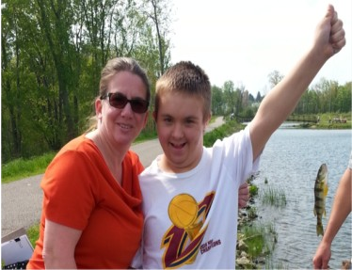
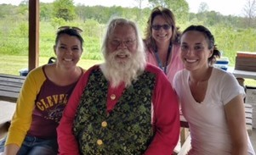
great learning experience work- and the Geauga Park District. I ing with all the district staff, the would like to say “thank you” Special Education Directors, and again to the Chardon Rotary for helping over 100 families this a fun fishing day at the year. I hope everyone has an Walter C. Best Wildlife enjoyable summer with their Preserve on May 17th. loved ones. If you are looking My son had a blast for summertime activities for catching fish, and as

Board Recognition
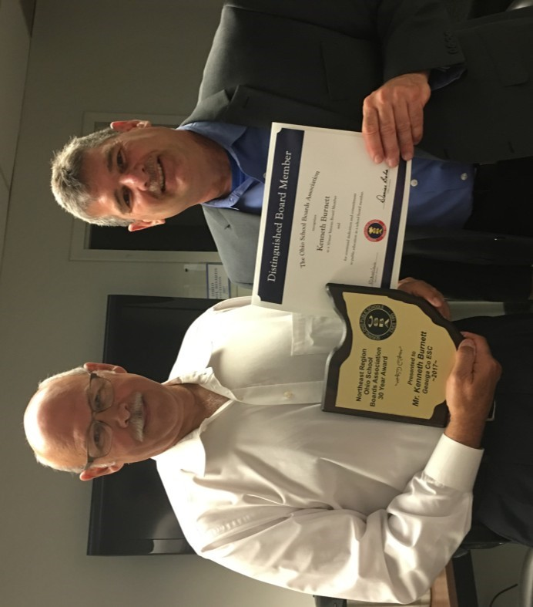
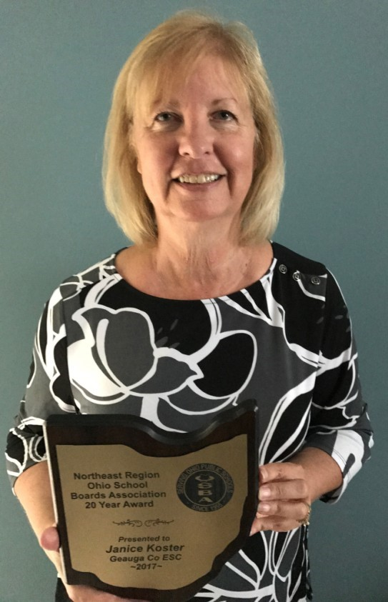
CONGRATULATIONS to our Board
Members, Ken Burnett for receiving the Ohio School Boards Association 30 years of service award and Janice Koster, 20 years of service award.

Reno Contipelli from Ohio School Board Association presented the awards.

Carrington, Michael Abraham
Carrington Youth Academy is providing the food and our teacher Amber Morvilius is volunteering a | Carrington  School will be having its Summer School program beginning June 5 and running
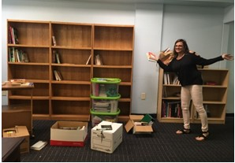
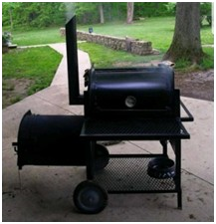
Carrington School will be cele- a table for brating the end of the regular school year board games on Thursday, May 25 with a school-wide and an area for cookout on Friday, jointly hosted by the small group school and Carrington Youth Academy. instruction.
smoker and her time to through the end of July. Summer school prepare a summer barbe-is a full program, replicating the regular que for the students. school year. Teachers Thomas Gephart,
We are putting the last Murray Katz and Peggy O’Brien will be
touches on setting up our library, with books and shelving donated by one of our regular substitute teachers, Patrice Mishaga. It should be in place by the time Summer School starts. Our plan is for the space to include the lending library, a reading space, | returning to teach summer school classes. Students have the opportunity to earn up to another quarter of a credit in each of English, Math, Social Studies and Science.
Nursing, Jennifer Klock  Camp Ho Mita Koda is a camp for children with diabetes in Newbury that has been operating for 87 years. The oldest camp of its kind in the nation. A new nonprofit, the Camp Ho Mita Koda Foundation, will continue to offer the high quality programming, around the clock medical care, and amazing summer experience historically provided at Camp Ho Mita Koda. Many of the camp management staff, medical staff and counselors for 2017 have previously worked at the camp. It | will offer two separate weeks of overnight camp in 2017 from July 9-14 for ages 8-11 and July 16-21 for ages 12-15, as well as day camp July 16-18 for ages 5-11. The goals is to continue to provide scholarships to allow as many children as possible to participate. To learn more and register go to www.chmkfoundation.org.  The end of the year fishing trip at Walter C. Best Wildlife Preserve is always one of my favorites! It was so nice to see all of our kiddos in the Geauga Achieve &
STARS program, including Chardon's
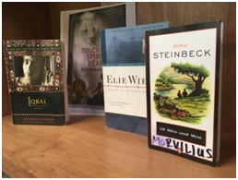
Students completed reading Of Mice and Men in English class. Here is a picture of some of the other books read in English class. Students have been completing a study of some of the causes of World War II in Social studies and continuing Financial Literacy instruction as a joint instruction in math with Murray Katz and in social studies with Thomas Gephart. Since we cannot use scalpels at Carrington School the students instead did a paper/pencil dissection of a frog as part of a unit on biology.
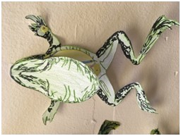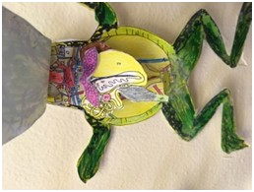
class with teacher Maria Lysiak, attended and enjoyed the beautiful weather. Their smiles said it all...not to mention their excitement when they caught a fish! It was a fun way for all to end another wonderful school year.!

The Geauga ESC Preschool continues to enroll students for the 2017-2018 school year. Interested families can learn more and obtain enrollment information by visiting the ESC website or by calling (440)729-0137. Tuition assistance is available to those who qualify.  Children in our preschool classrooms have engaged in play based learning throughout the school year and have had the opportunity to interact with many community organizations. | Our students are fortunate to be able to participate in programs presented by the Geauga Park District, weekly music classes offered by Metzenbaum staff, and visits from the Geauga County Public Library. Teachers are working to send fun and engaging summer packets home with students and have equipped students with skills necessary to successfully transition to kindergarten.

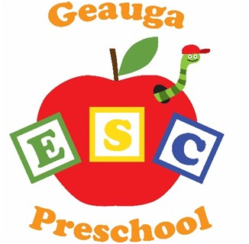 Preschool, Shelby Kaminski 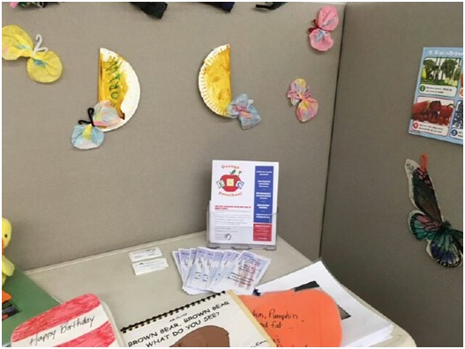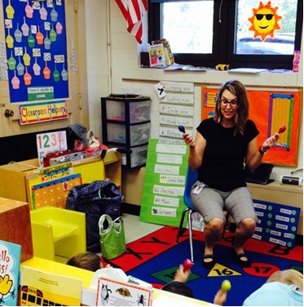

STARS, Dana Eggers
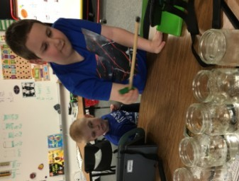
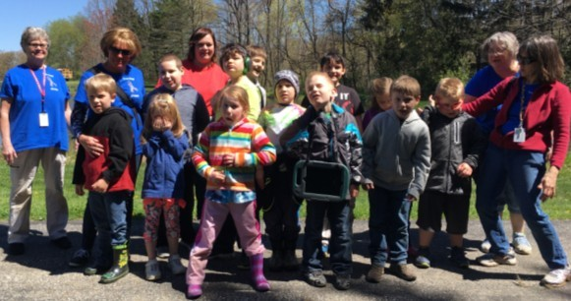
The STARS staff and students are excited for the end of the school year. We have had a very busy and successful year. Two of our students will be graduating and moving on to the “work-force”. Both students have made such amazing progress in our program and we will miss them tremendously. Our students have participated in many community outings which have allowed for generalization of skills as well as building community awareness of individuals with autism. Each year, we are amazed by the amount of support and kindness our classrooms receive from community agencies. We are thankful for Pat Preston at Preston Superstore. His monetary contribution to our program supports purchasing of technology equipment as well as classroom supplies for our students to continue to make progress across all areas.
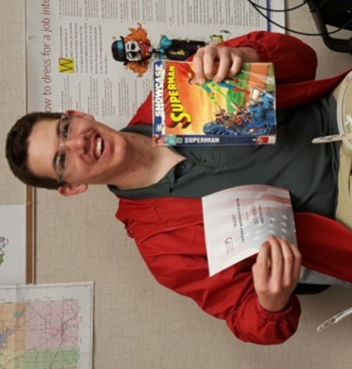
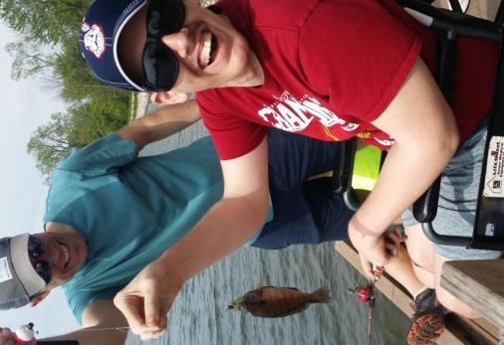
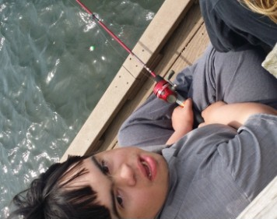
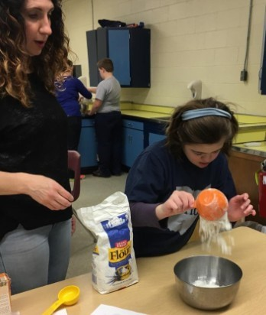
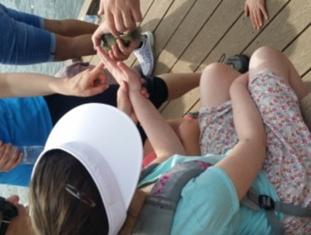
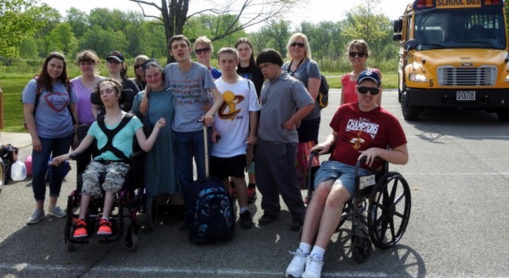
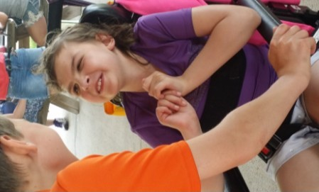
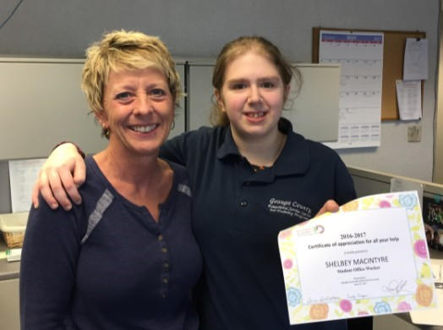
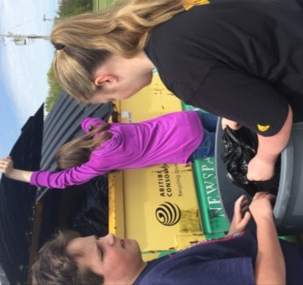
We are often amazed at the ability of our students, and this year is no different. Each student has made progress, some big accomplishments, some little, and we are honored to be a part of each students’ success. We truly recognize that the growth of our students is dependent on collaboration with families, and we are thankful each day for our positive family relationships.
Geauga Achieve, Robin Ludwig

Another amazing year is complete in
the Geauga ACHIEVE Program. Our
students have been engaged in many
lessons and activities over this last quar-
ter, but they have most enjoyed their
outings in the community and the an-
nual fishing trip with the Rotary Clubs
of Geauga County. These opportunities
to demonstrate and generalize the skills
that have been learned in the classroom
are essential components for the educa-
tion of our students. We are so lucky
to have a supportive community that
helps us to create these opportunities.
Thank you to all who have supported us
throughout the 2016
-
school year. We
2017
are already preparing for the return of the
students in August so that we can have
another productive year full of learning and
growth. In the meantime, we will enjoy the
fun of summer and family and wish every-
one a safe and happy break!

We are looking forward to next year!
A Special Thanks to ALL of our Student Office Assistants!!
We appreciate all your hard work.
Wishing you all a fun & safe summer!

